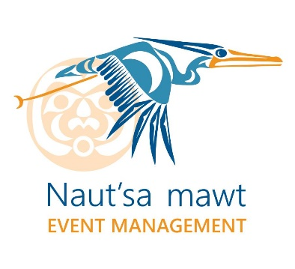
Claims are due NO LATER THAN 30 days following the conclusion of the event.
Travel Expense Claim Form

Date Submitted:
Location of Event: |  | JW Marriott Parq Vancouver: 39 Smithe St, Vancouver, BC V6B 0R3 (604.676.0888)
Date of Event: |  | May 16, 17 & 18, 2023
Contact Details (Please note: payment will be mailed to the address provided below.)
Attendee Name:
Payable to:
Address:
City: |  |  | Postal Code: |  |  |  |  |  |  | Phone Number:
Accommodation (Accommodations may be provided up to a total of 3 nights – subject to your travel itinerary)
Marriott PARQ Hotel | Night(s) | Please confirm your Reservation #
Other Hotel (attach receipts) | Night(s) @ |  | Total Hotel | $

Meals (No receipt required) Please do not claim for meals that are provided at the event.
 |  | Travel Day-May 15, (if applicable) | May 16 |  | May 17 |  |  | May 18 |  |  | Travel Day- May 19, (if applicable) |  |  | Total
Breakfast @ $22.80 |  |  | Provided |  | Provided |  |  | Provided
Lunch @ 23.05 |  |  | Provided |  | Provided |  |  | Provided
Dinner @ $56.60
Incidentals @ $17.30
Transportation (Please attach receipts except where noted)
 |  | Description |  |  |  |  |  |  |  |  |  |  |  | Total
Airfare (receipt required) ECONOMY |  |  |  |  |  |  |  |  |  |  |  |  |  | $
Ferry/Boat (receipt required) |  |  |  |  |  |  |  |  |  |  |  |  |  | $
Taxi/Water Taxi (receipt required) |  |  |  |  |  |  |  |  |  |  |  |  |  | $
Self-Parking (receipt required)  - Valet Excluded |  |  |  |  |  |  |  |  |  |  |  |  |  | $
Private Vehicle (no receipt required) |  | # kms = |  | @$0.57/km |  |  |  |  | Subtotal Private Vehicle |  |  |  |  | $
Signature of attendee: |  |  |  |  |  |  | Initials |  | Total Reimbursement |  |  |  |  | $
Please email claim with any required original receipts to:
Naut’sa mawt Tribal Council – Attn: accounting@nautsamawt.com or by mail to PO Box 21029, Duncan BC, V9L 0C2
To guarantee reimbursement, please submit no later than 30 days (June 15, 2023) after the event has concluded.
Questions about this form? Email Adrien Castle at acastle@nautsamawt.com
or call the NmTC office at 604-943-6712 or 1-888-382-7711 (toll free)

Company Code: GL Account: Profit Centre: Sub-Account:

REQUIRED

Direct Deposit / Electronic Funds Transfer (EFT)
Expense Claim Payment

Instructions: Please complete all sections of this section and attach either a void check or a copy of your Customer Account Information form from your banking institution.

Note: Your expense claim cannot be processed without this documentation.

Account Information

Transit Number_________________________________________________

Institution Number ______________________________________________

Account Number ________________________________________________

Participant Signature_____________________________________________

Print Name _____________________________________________________

Date ___________________________________________________________

